DIGITAL TRANSFORMATION
- What is Digital Transformation?
The development of new competencies revolves around the capacities to be more agile, people-oriented, innovative, customer-centric, streamlined, efficient and able to induce/leverage opportunities to change the status quo and tap into new data sources – and service-driven revenues. Digital transformation efforts and strategies are often more urgent and present in markets with a high degree of commoditization.

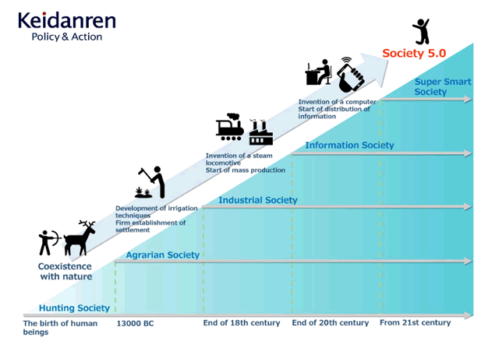
- Society 5.0

One definition: "A human-centered society that balances economic advancement with the resolution of social problems by a system that highly integrates cyberspace and physical space."
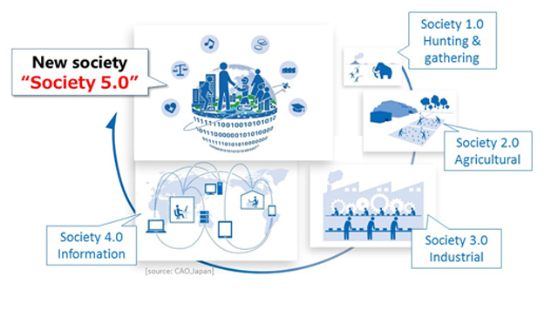
Society 5.0 was proposed in the 5th Science and Technology Basic Plan as a future society that Japan should aspire to. It follows the hunting society (Society 1.0), agricultural society (Society 2.0), industrial society (Society 3.0), and information society (Society 4.0).

Because there is a limit to what people can do, the task of finding the necessary information from overflowing information and analyzing it was a burden, and the labor and scope of action were restricted due to age and varying degrees of ability. Also, due to various restrictions on issues such as a decreasing birthrate and aging population and local depopulation, it was difficult to respond adequately.
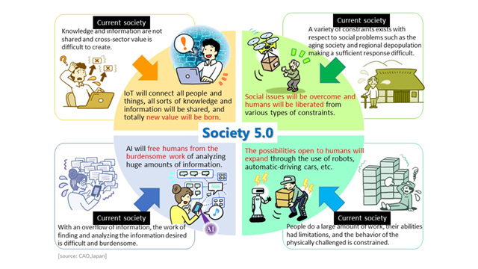
Social reform (innovation) in Society 5.0 will achieve a forward-looking society that breaks down the existing sense of stagnation, a society whose members have mutual respect for each other, transcending the generations, and a society in which each and every person can lead an active and enjoyable life.

Society 5.0 achieves a high degree of convergence between cyberspace (virtual space) and physical space (real space). In the past information society (Society 4.0), people would access a cloud service (databases) in cyberspace via the Internet and search for, retrieve, and analyze information or data.
In Society 5.0, a huge amount of information from sensors in physical space is accumulated in cyberspace. In cyberspace, this big data is analyzed by artificial intelligence (AI), and the analysis results are fed back to humans in physical space in various forms.
In the past information society, the common practice was to collect information via the network and have it analyzed by humans. In Society 5.0, however, people, things, and systems are all connected in cyberspace and optimal results obtained by AI exceeding the capabilities of humans are fed back to physical space. This process brings new value to industry and society in ways not previously possible.
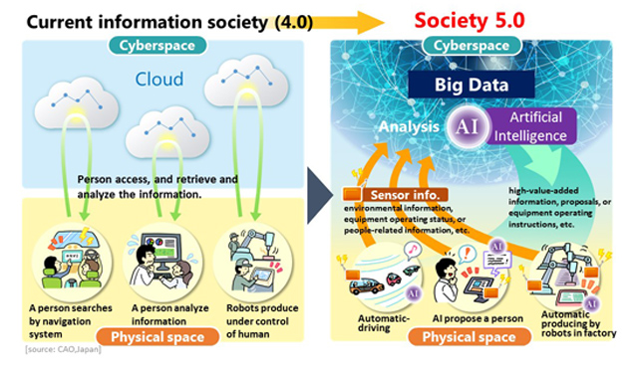

In Society 5.0, new value created through innovation will eliminate regional, age, gender, and language gaps and enable the provision of products and services finely tailored to diverse individual needs and latent needs. In this way, it will be possible to achieve a society that can both promote economic development and find solutions to social problems.
Achieving such a society, however, will not be without its difficulties, and Japan intends to face them head-on with the aim of being the first in the world as a country facing challenging issues to present a model future society.
This is a society centered on each and every person and not a future controled and monitored by AI and robots.

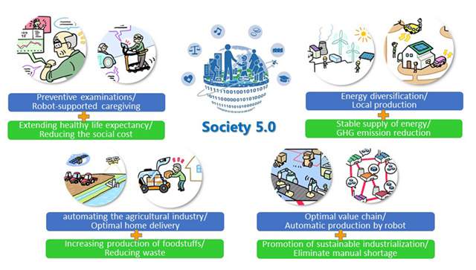
Achieving Society 5.0 with these attributes would enable not just Japan but the world as well to realize economic development while solving key social problems. It would also contribute to meeting the Sustainable Development Goals (SDGs) established by the United Nations.
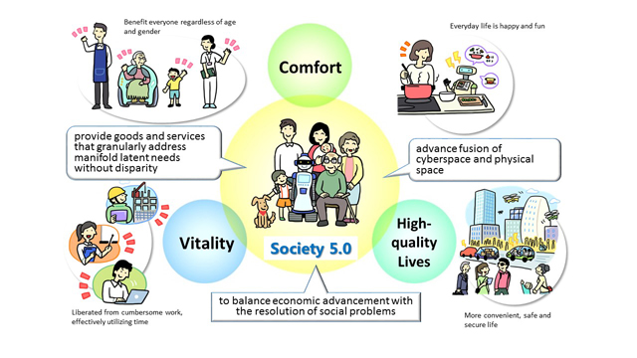

- What is 5G?
Peak data rate: 5G will offer significantly faster data speeds. Peak data rates can hit 20Gbps downlink and 10Gbps uplink per mobile base station. Mind you, that’s not the speed you’d experience with 5G (unless you have a dedicated connection) — it’s the speed shared by all users on the cell.
Real-world speeds: While the peak data rates for 5G sound pretty impressive, actual speeds won’t be the same. The spec calls for user download speeds of 100Mbps and upload speeds of 50Mbps.
Latency: Latency, the time it takes data to travel from one point to another, should be at 4 milliseconds in ideal circumstances, and at 1 millisecond for use cases that demand the utmost speed. Think remote surgeries, for instance.
Efficiency: Radio interfaces should be energy efficient when in use, and drop into low-energy mode when not in use. Ideally, a radio should be able to switch into a low-energy state within 10 milliseconds when no longer in use.
Spectral efficiency: Spectral efficiency is “the optimized use of spectrum or bandwidth so that the maximum amount of data can be transmitted with the fewest transmission errors.” 5G should have a slightly improved spectral efficiency over LTE, coming in at 30bits/Hz downlink, and 15 bits/Hz uplink.
Mobility: With 5G, base stations should support movement from 0 to 310 mph. This basically means the base station should work across a range of antenna movements — even on a high-speed train. While it’s easily done on LTE networks, such mobility can be a challenge on new millimeter wave networks.
Connection density: 5G should be able to support many more connected devices than LTE. The standard states 5G should be able to support 1 million connected devices per square kilometer. That’s a huge number, which takes into account the slew of devices that will power the Internet of Things (IoT).

- What Can 5G Do?

Improve broadband
The shift to 5G will undoubtedly change the way we interact with technology on a day-to-day basis, but it’s also an absolute necessity if we want to continue using mobile broadband.
Carriers are running out of LTE capacity in many major metropolitan areas. In some cities, users are already experiencing slowdowns during busy times of the day. 5G adds huge amounts of spectrum in bands that haven’t been used for commercial broadband traffic.
Autonomous vehicles
Expect to see autonomous vehicles rise at the same rate that 5G is deployed across the U.S. In the future, your vehicle will communicate with other vehicles on the road, provide information to other cars about road conditions, and offer performance information to drivers and automakers. If a car brakes quickly up ahead, yours may learn about it immediately and preemptively brake as well, preventing a collision. This kind of vehicle-to-vehicle communication could ultimately save thousands of lives.
Public safety and infrastructure
5G will allow cities and other municipalities to operate more efficiently. Utility companies will be able easily track usage remotely, sensors can notify public works departments when drains flood or streetlights go out, and municipalities will be able to quickly and inexpensively install surveillance cameras.
Remote device control
Since 5G has remarkably low latency, remote control of heavy machinery will become a reality. While the primary aim is to reduce risk in hazardous environments, it will also allow technicians with specialized skills to control machinery from anywhere in the world.
Health care
The ultra-reliable low latency communications (URLLC) component of 5G could fundamentally change health care. Since URLLC reduces 5G latency even further than what you’ll see with enhanced mobile broadband, a world of new possibilities opens up. Expect to see improvements in telemedicine, remote recovery, and physical therapy via AR, precision surgery, and even remote surgery in the coming years.
Remember massive Machine-Type Communications? mMTC will also play a key role in health care. Hospitals can create massive sensor networks to monitor patients, physicians can prescribe smart pills to track compliance, and insurers can even monitor subscribers to determine appropriate treatments and processes.
IoT
One of the most exciting and crucial aspects of 5G is its effect on the Internet of Things. While we currently have sensors that can communicate with each other, they tend to require a lot of resources and are quickly depleting LTE data capacity.
With 5G speeds and low latencies, the IoT will be powered by communications among sensors and smart devices (here’s mMTC again). Compared to current smart devices on the market, mMTC devices will require fewer resources, since huge numbers of these devices can connect to a single base station, making them much more efficient.
- Project Statement Ideation Outcomes:

- FROM SOIL TO TABLE
Supporting agricultural methods that change with digital transformation with individual production. Reducing waste production and positive inclusion of waste in the process, with solutions that enable the user to easily produce their own organic food for an environmental friendly, healthy and sustainable lifestyle. Maybe self-grown foods.

- GET ME OUT OF HERE
Providing solutions to users in case of danger or disaster. The aim of the user is to manage the situation in cases of casualty, disaster and danger, when the aid does not come immediately or when it is not known, and to provide the user with solutions and opportunities at/after the time of the event.

- EASY AND FAST, HEALTHY MEALS
Reducing ready-to-eat food consumption that comes with a fast lifestyle. Although ready-made foods cause many allergies and diseases, they are preferred by today's people because they are fast and practical. Encouraging the meals prepared by the user in a healthy way by facilitating and speeding up the process.
- ALL DAY BY ME

With the increasing use of thermos, water bottles and storage containers, which have become widespread with increasing healthy nutrition and high quality product consumption trends, the problem of users to carry dirty products or to refill them all day long, even though they consume it for a short time.

- SOLUTIONS FOR WINTER CAMPING

In the winter months when the water source is hard to reach while camping (if there is no water source, snow is melted by certain methods and water is obtained), making it easier for the user to obtain water.

Compact gas stove and self-cleaning shrinkable food kit. Since there are no water, the cooking kits are cleaned by rubbing with snow. Enhancing the experience of winter campers.

- COOKING WITH CHILDREN

Increasing the bond between parent and child through food preparation activity. Teaching the healthy nutrition by giving the child the habit of preparing food from a young age.

- WHERE ARE I, WHO

Alzheimer patients who are in a difficult situation at the moment of attack are calmed and directed to be removed from the dangerous situation.

- Proje Konuları:

- TOPRAKTAN SOFRAYA
Dijital dönüşümle beraber değişen tarım yöntemlerinin, bireysel üretimle desteklenmesi. Çevreci, sağlıklı ve sürdürülebilir bir yaşam tarzı için, kullanıcının kolaylıkla kendi organik besinini kendi üretmesini sağlayan çözümler ile birlikte atık üretiminin azaltılması ve atıkların sürece pozitif olarak dahil edilmesi. Belki kendi kendini yetiştiren besinler.

- BENİ TEHLİKEDEN ÇIKAR
Tehlike veya afet anında kullanıcılara çözüm sunulması. Kazazede, afetzede ve tehlike durumundaki insanlara, yardımın hemen gelmediği ve ya ne zaman geleceğinin bilinmediği durumlarda kullanıcının durumu yönetmesinin amaçlanması ve kullanıcıya olay anında ve/ve ya sonrasında çözüm yolları, olanaklar sağlanması.

- KOLAY VE HIZLI, SAĞLIKLI YEMEKLER
Hızlı yaşam tarzıyla beraber ortaya çıkan hazır gıda tüketimini azaltmak. Hazır gıdalar birçok alerji ve hastalığa neden olmasına rağmen hızlı ve pratik oldukları için günümüz insanı tarafından sık tercih edilmektedir. Sağlıklı ve katkısız bir şekilde kullanıcı tarafından hazırlanan yemeklerin süreci kolaylaştırarak ve hızlandırarak özendirilmesi.

- TÜM GÜN YANIMDA
Artan sağlıklı beslenme ve kaliteli ürün tüketme trendleriyle beraber yaygınlaşan termos, su şişesi, saklama kabı kullanımının artması üzerine, kullanıcıların kısa süreliği tüketmesine rağmen tüm gün yanlarında kirli ürünleri taşımaları, ya da tekrar doldurmalarının gerekmesi konusun çözülmesi.

- KIŞ KAMPÇILIĞI İÇİN ÇÖZÜMLER
Kamp yaparken su kaynağına zor ulaşılan kış aylarında (su kaynağı yoksa, kar belli yöntemlerle eritilerek su elde edilir), kullanıcının su elde etmesinin kolaylaştırılması.
Kompakt gaz ocağı ve kendini temizleyen küçülebilen yemek kiti. Yemek kitleri su olmadığı için karla ovularak temizlenmektedir normalde. Kış kampçılarının deneyimlerinin olumlulaştırılması.

- ÇOCUKLARLA PİŞİRMEK
Ebeveyn ve çocuk arasındaki bağın yemek hazırlama aktivitesi aracılığıyla arttırılması. Çocuğa küçük yaştan itibaren, yemek hazırlama alışkanlığının kazandırılarak, sağlıklı beslenmenin öğretilmesi.

- BEN NERDEYİM, KİMİM
Atak anında zor durumda kalan Alzaymır hastalarının sakinleştirilerek ve yönlendirilerek tehlikeli durumdan çıkarılmaları.
- References

- https://www.i-scoop.eu/digital-transformation/
- https://www8.cao.go.jp/cstp/english/society5_0/index.html
- https://www.digitaltrends.com/mobile/what-is-5g/
- https://www.i-scoop.eu/industry-4-0/society-5-0/
- https://www.i-scoop.eu/industry-4-0/
- https://www.smashingmagazine.com/2013/05/50-problems-50-days-part-1-real-empathy-innovation/

